6MP HD Vandal-resistant IR Fixed Dome Network Camera
IPC326LE-ADF28K-H
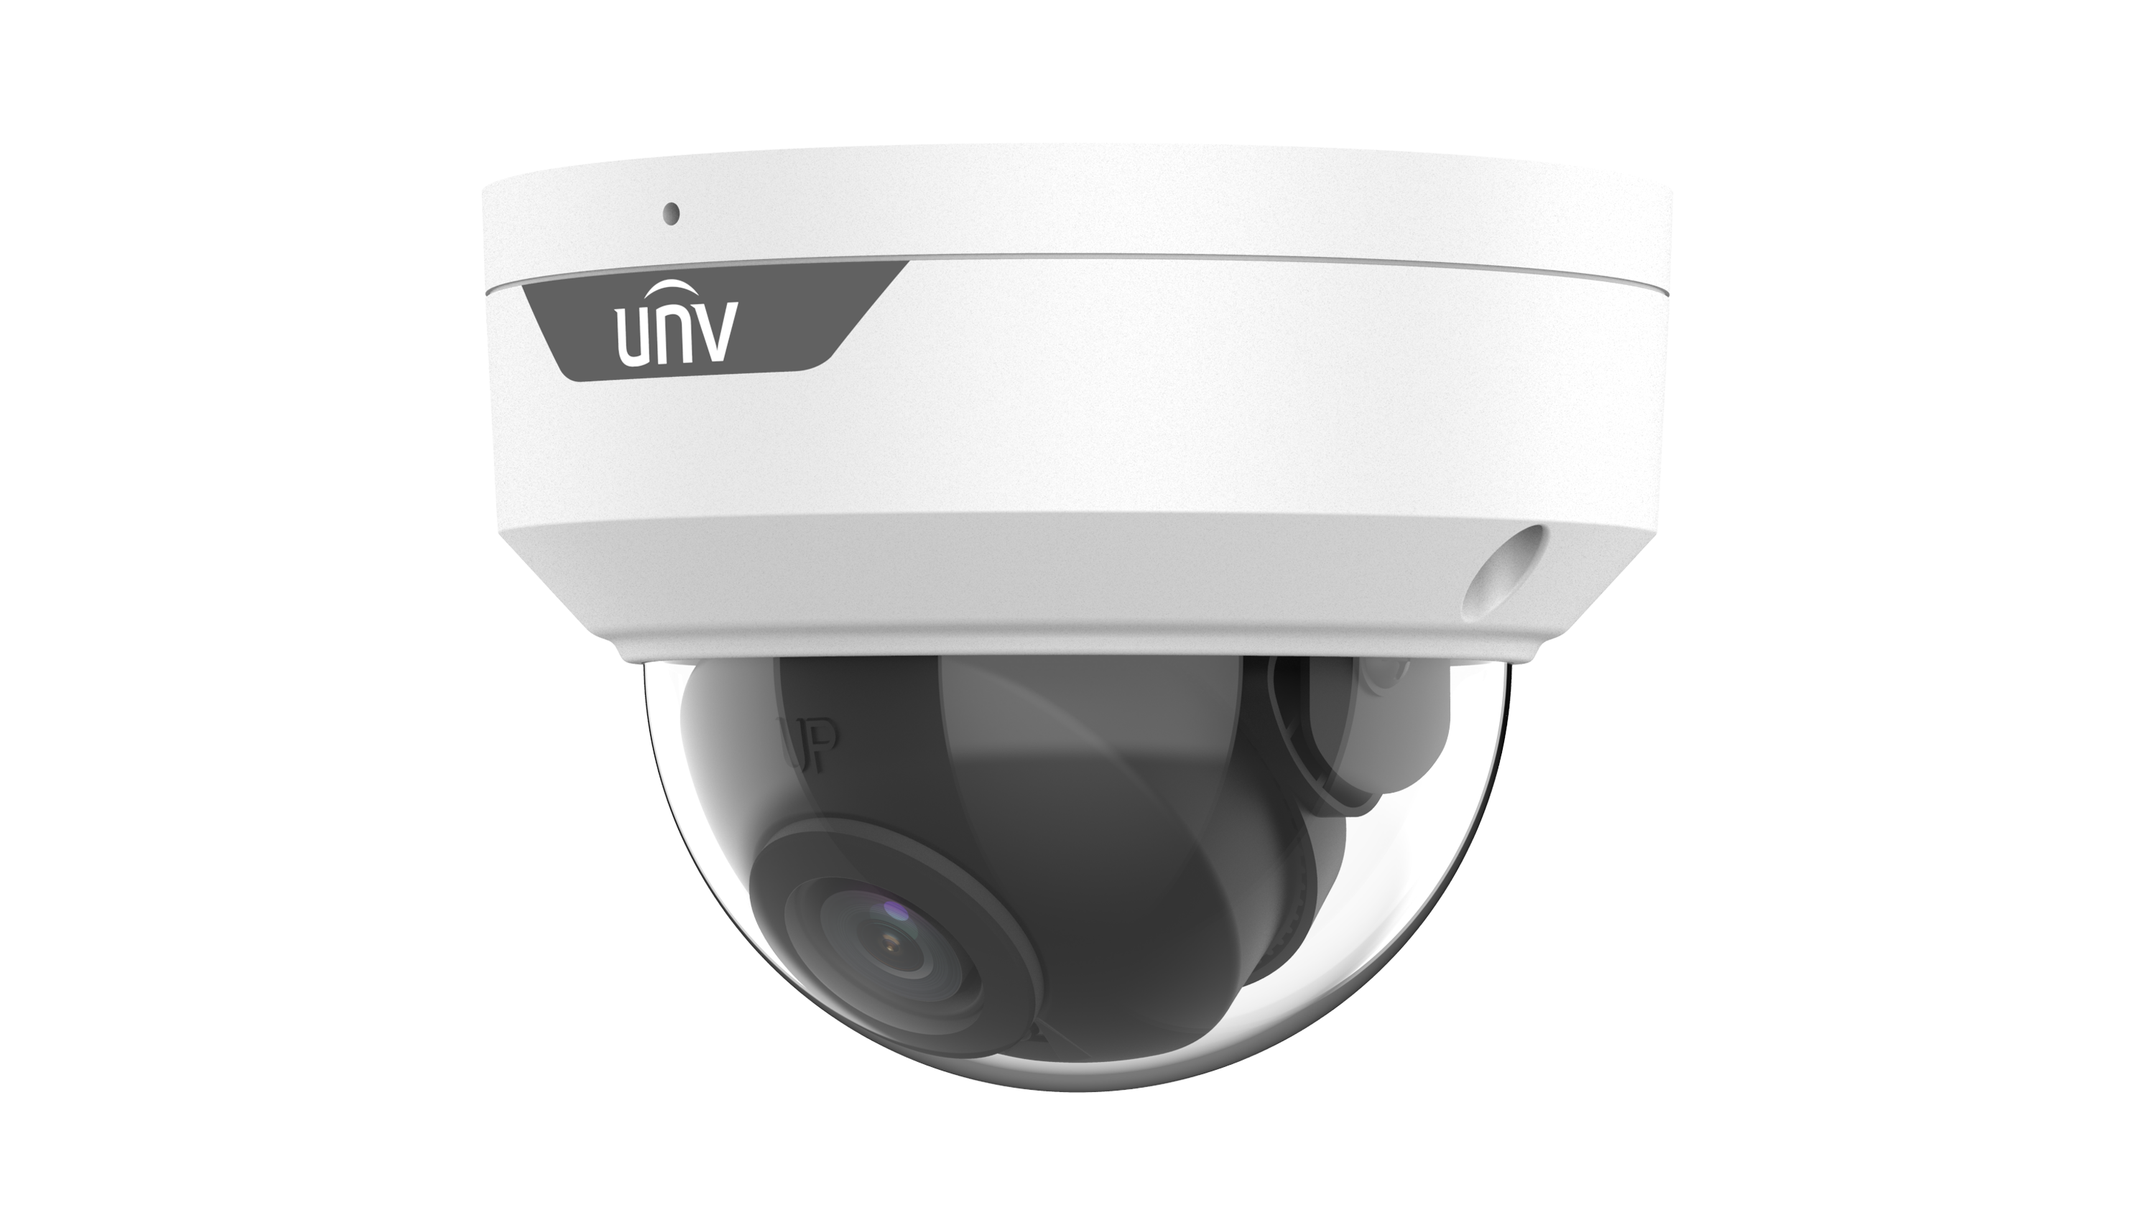
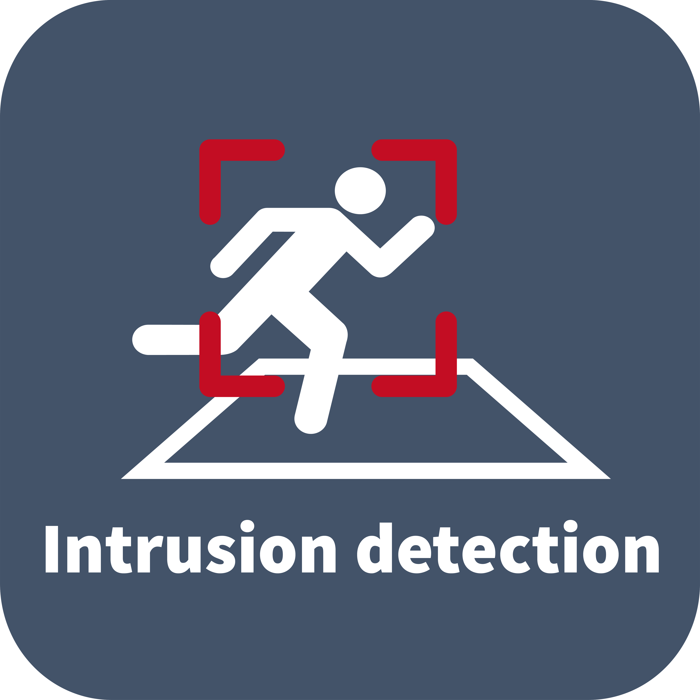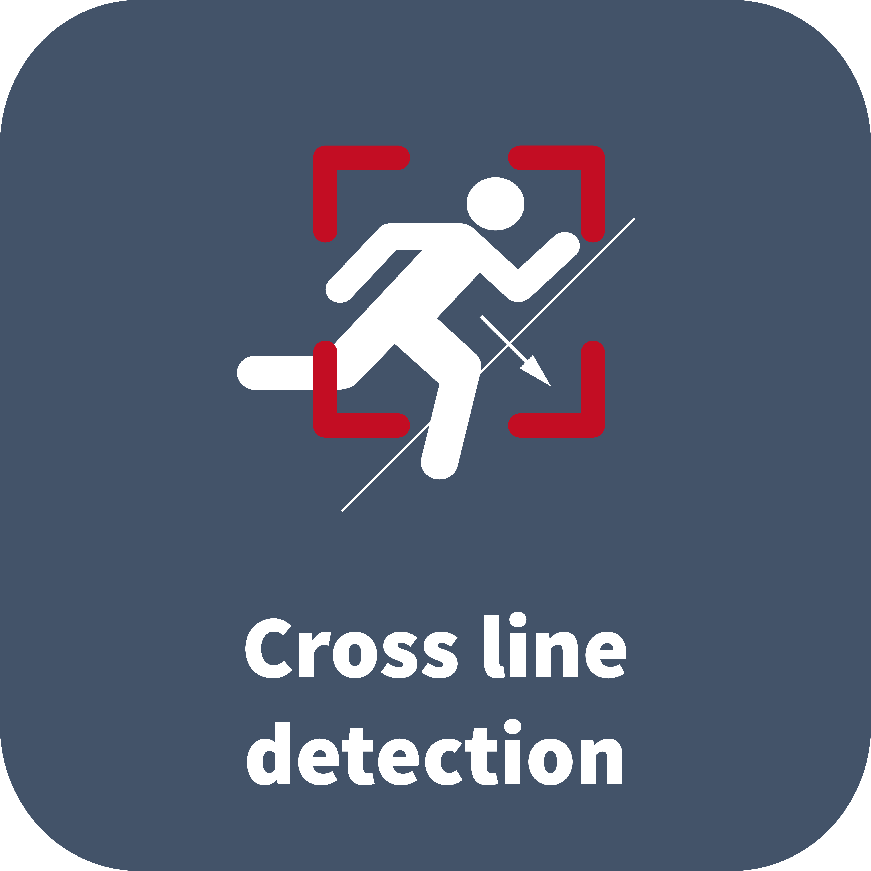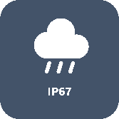

Features
- High quality image with 5MP, 1/2.7" CMOS sensor
- 6MP@25fps
- Ultra 265, H.265, H.264, MJPEG
- Easystar technology ensures high image quality in low illumination environment
- 120 dB true WDR technology enables clear image in strong light scene
- Built-in Mic
- Smart IR, up to 30 m (98 ft) IR distance
- Supports up to 512 GB Micro SD Card
- IK10 vandal resistant
- IP67 protection
- Support PoE power supply
- 3-Axis

Specifications
Model | IPC325LE-ADF28K-H
Camera
Max Resolution | 6 MP
Sensor | 1/2.7" CMOS
Min. Illumination | Colour: 0.003 lux ( F1.6, AGC ON)  0 Lux with IR on
Day/Night | IR-cut filter with auto switch (ICR)
Shutter | Auto/Manual, 1 ~ 1/100000s
Adjustment Angle | Pan: 8° ~ 360°, Tilt: 0° ~ 68°, Rotate: 10° ~ 360°
S/N | >52 dB
WDR | 120 dB
Lens
Focal Length | 2.8 mm
Iris Type | Fixed
Iris | F1.6
Field of View (H)
Field of View (V)
Field of View (D)
DORI
DORI Distance (Lens) | 2.8mm
DORI Distance (Detect) | 63.0m(206.7t)
DORI Distance (Observe) | 25.2m(82.7ft)
DORI Distance (Recognize) | 12.6m(41.3ft)
DORI Distance (Identify) | 6.3m(20.7ft)
Illuminator
Supplemental Light | IR
Illumination Distance (IR) | 30 m (98.4 ft)
Wavelength | 850 nm
IR On/Off Control | Auto/Manual
Video
Video Compression | Ultra 265, H.265, H.264, MJPEG
H.264 Code Profile | Baseline profile, Main profile, High profile
Frame Rate | Main Stream: 6MP, Max 25fps;
Video Bit Rate | 128 Kbps to 6144 Kbps
U-code | Support
OSD | Up to 4 OSDs
Privacy Mask | Up to 4 areas
ROI | Support
Video Stream | Dual streams
Image
White Balance | Auto, Outdoor, Fine tune, Sodium lamp, Locked, Auto2
Digital Noise Reduction | 2D/3D DNR
Smart IR | Support
Flip | Normal, Flip vertical, Flip horizontal, 180°
Dewarping | N/A
HLC | Support
BLC | Support
Defog | Digital defog
Events
Basic Detection | Cross line (based on human body detection), Intrusion (based on human body detection), Motion detection, Tampering alarm, Audio detection
General Function | Watermark, IP address filtering, Access policy, ARP protection, RTSP authentication, User authentication
Audio
Audio Compression | G.711U, G.711A
Audio Bitrate | 64 Kbps
Two-way Audio | N/A
Suppression | Support
Sampling Rate | 8 kHz
Storage
Edge Storage | Micro SD, up to 512 GB
Network Storage | ANR, NAS (NFS)
Network
Protocols | IPv4, IGMP, ICMP, ARP, TCP, UDP, DHCP, RTP, RTSP, RTCP, RTMP, DNS, DDNS, NTP, FTP, UPnP, HTTP, HTTPS, SMTP, QoS, SSL/TLS, 802.1x, SNMP
Compatible Integration | ONVIF (Profile S, Profile G, Profile T),  API, SDK
User/Host | Up to 32 users. 3 user levels: administrator, common user and operator
Security | Password Protection, Strong Password, HTTPS Encryption, Export Operation Logs, Basic and Digest Authentication for RTSP, Digest Authentication for HTTP, TLS 1.2, WSSE and Digest Authentication for ONVIF
Client | UNV-Link, UNV-Link Pro, EZStation
Web Browser | Plug-in required live view: IE 10+, Chrome 45+, Firefox 52+, Edge 79+, Plug-in free live view: Chrome 57+, Firefox 58+, Edge 16+
Interface
Audio I/O | N/A
Alarm I/O | N/A
Serial Port | N/A
Built-in Mic | Support
Built-in Speaker | N/A
WIFI | N/A
Network | 1 × RJ45 10 M/100 M Base-TX Ethernet
Video Output | N/A
Certification
EMC | CE-EMC (EN 55032, EN 61000-3-3, EN IEC 61000-3-2, EN 55035)  FCC (FCC 47 CFR part15 B)
Safety | CE LVD (EN 62368-1)  UL/CUL (UL 62368-1, CAN/CSA C22.2 No. 62368-1)
Environment | CE-RoHS (2011/65/EU;(EU)2015/863); WEEE (2012/19/EU);
Protection | IP67 (IEC 60529)  IK10 (IEC 62262)
General
Power | DC 12V±25%, PoE (IEEE 802.3af)
Power Consumption | Max 4.4W
Power Interface | Ø5.5 mm coaxial power plug
Dimensions | Ø111 x 83mm (Ø4.4” x 3.3”) (Ø x H)
Weight | 0.35kg (0.77lb)
Material | Metal + Plastic
Working Environment | -30 ℃ to 60 ℃ (-22 ℉ to 140 ℉), Humidity: ≤ 95% RH (non-condensing)
Storage Environment | -30 ℃ to 60 ℃ (-22 ℉ to 140 ℉), Humidity: ≤ 95% RH (non-condensing)
Surge Protection | 4 KV
Reset Button | Support
Web Client Language | 13 Languages: English, Simplified Chinese, Polish, German, Russian, French, Korean, Dutch, Czech, Portuguese, Spanish, Spanish (Europe), Italian

Dimensions
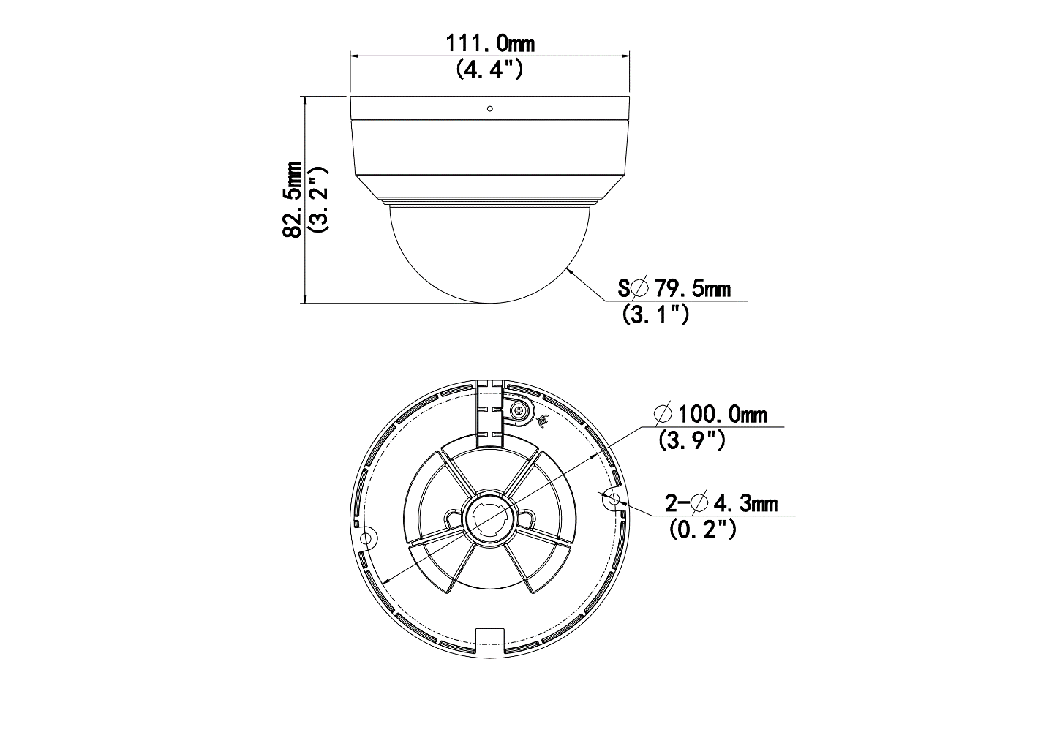

Accessories
TR-JB03-G-IN | TR-JB07/WM03-G-IN | TR-WM03-D-IN
Junction Box for Mini Fix-dome(Support wiring from behind) | Wall Mounting Assembling Bracket For 32 Fix-dome&Mini Fix-dome&Plastic Turret Camera | Wall Mounting Bracket for 32 Fix-dome&Mini Fix-dome&Plastic Turret Camera
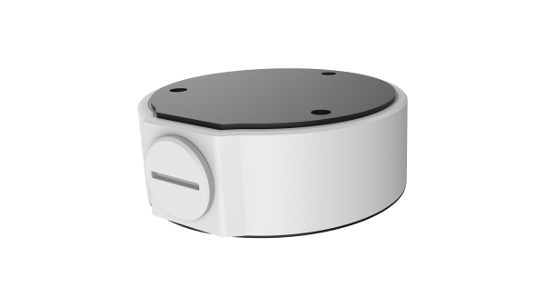 | 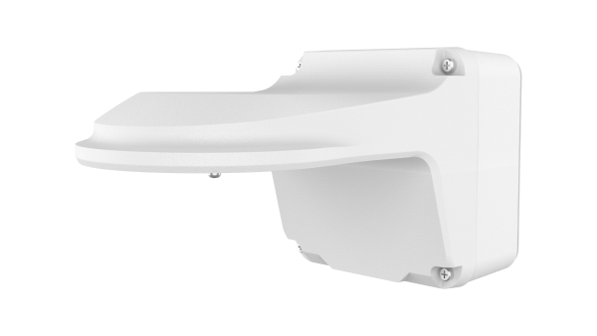 | 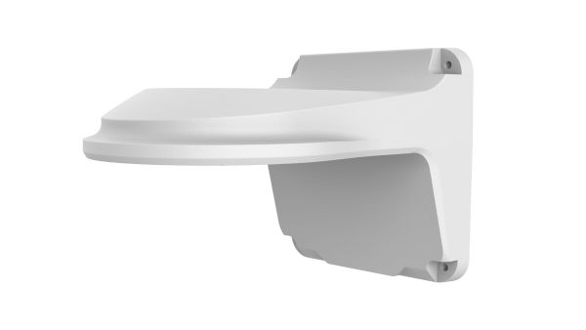
TR-UM06-E-IN | TR-A01-IN | TR-UP06-IN
Slant Mounting Bracket for Fixed Dome | NPT 3/4'' Waterproof Cable Gland | Universal Pole Mounting Bracket
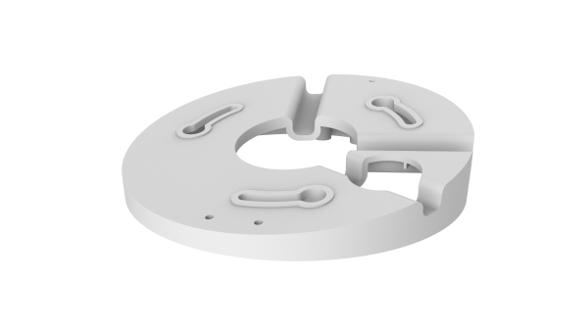 | 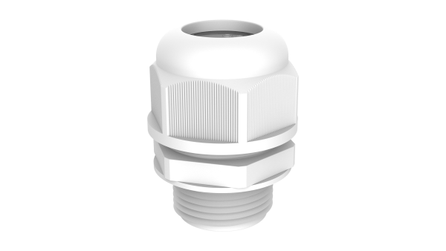 | 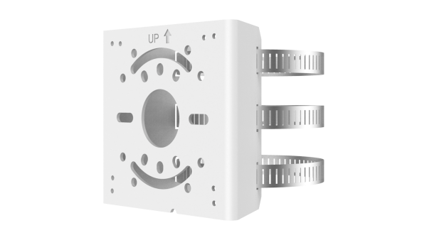
TR-UC08-C | TR-SE24-IN | TR-SE24-A-IN
Bullet&Dome Corner Mounting Bracket | Dome Pendent Mounting Pole 200mm | Dome Pendent Mounting Pole 500mm
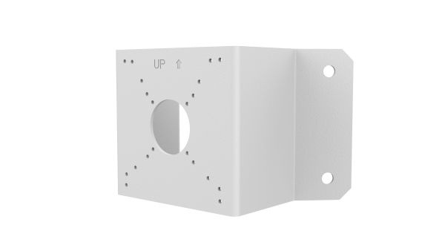 | 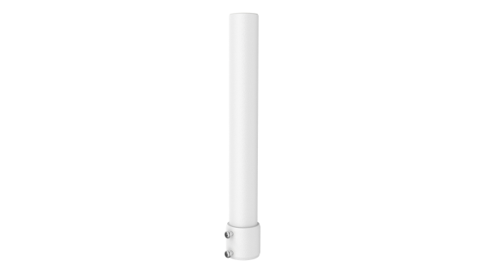 | 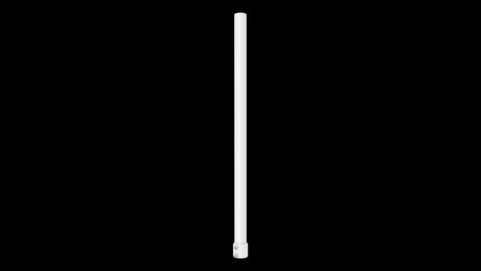
TR-CM24-IN
Dome Pendent Mounting Bracket(Indoor)
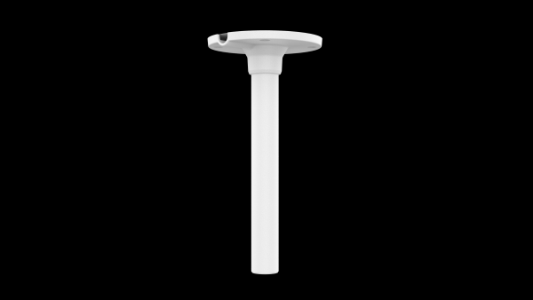

Zhejiang Uniview Technologies Co., Ltd.
No. 369, Xietong Road, Xixing Sub-district, Binjiang District, Hangzhou City, 310051, Zhejiang Province, China
Email: overseasbusiness@uniview.com; globalsupport@uniview.com
http://www.uniview.com
©2024-2025 Zhejiang Uniview Technologies Co., Ltd. All rights reserved.
*Product specifications and availability are subject to change without notice.
*Despite our best efforts, technical or typographical errors may exist in this document. Uniview cannot be held responsible for any such errors and reserves the right to change the contents of this document without prior notice.

